2025 Bachelor’s Graduation Thesis

Development of a CAM System for Incremental Forming of CFRTP from 3D CAD Data

Precision Engineering Research Group
Green Engineering and Applied Sciences Course
Faculty of Science and Technology
Sophia University

A2177802
Karter Wong

Guidance Professor Hidetake Tanaka
Submitted on 17 July 2022

Table of Contents
Chapter 1: Introduction 4
1.1 Background information: Incremental Forming 4
1.1.1 Development History 4
1.1.2 Types of Incremental Forming 4
Primary Types of Incremental Forming Error! Bookmark not defined.
- Single Point Incremental Forming (SPIF): 5
- Two Point Incremental Forming (TPIF): Error! Bookmark not defined.
- Double Sided Incremental Forming (DSIF): Error! Bookmark not defined.
1.1.3 Applications of Incremental Forming 5
1.2 NC Machine Tools 7
1.2.1 Overview 7
1.2.2 G-Code and Functions 8
1.2.3 3D CAD 8
1.2.4 CAM 9
1.2.5 Python 9
1.2.6 Tool Path 10
1.3 CFRP (Carbon Fiber Reinforced Plastic) 10
1.3.1 Overview 10
1.3.2 Classification and characteristics of CFRP 11
Thermosetting vs. Thermoplastic CFRP Error! Bookmark not defined.
Continuous vs. Discontinuous Fiber CFRP 11
1.3.3 CFRP Application Areas 11
1.3.4 CFRP Sample Used in This Study 11
1.4 Previous Research A 12
1.4.1 Overview 12
1.4.2 CAM and CAD System 12
1.4.3 Experimental Equipment 12
1.4.4 Results 13
1.4.5 Conclusions 13
1.5 Current Research Objectives 14
Chapter 2: Toolpath Generation 15
2.1 Program Overview 15
2.2 Libraries and Variables 15
libraries 15
Variables 15
2.3 Modules 15
Loading STL File and Extracting Point Cloud 15
Filtering Close Points to Prevent Clustering 15
Sorting Points to Prevent Doubling Back 15
Smoothing Hull Points Error! Bookmark not defined.
Applying Reverse Offset 15
2.4 Toolpath Generation Process 15
Main Toolpath Generation Loop 15
2.6 G-Code Generation and Export 15
2.7 NC Viewer Confirmation 15
Chapter 3: Experimental Equipment 16
3.1 Machining Center 17
3.2 Python Error! Bookmark not defined.
3.3 Discontinuous CFRTP 17
3.4 Oil Bath 17
3.5 Type of Oil 18
3.6 Forming Tool 18
3.7 Master mold 19
3.9 Jig Dimensions Error! Bookmark not defined.
Chapter 4: Incremental Forming Experiment 22
4.1 Experimental Setup 22
4.2 Procedure 23
4.3 Results 24
Chapter 5: Conclusion and Future Improvements 26
Appendix 27
Chapter 6: References 39

Chapter 1: Introduction

1.1 Background information: Incremental Forming
The demand for lightweight, durable, and sustainable materials in modern manufacturing has spotlighted Carbon Fiber Reinforced Plastics (CFRP) due to their high strength-to-weight ratio and excellent mechanical properties []. Traditional molding techniques, while efficient for high-volume production, significant costs for low-volume, complex CFRP components due to the need for custom molds []. The low volume production, in addition to the mold costs, increases manufacturing and consumer costs, limiting accessibility. Dieless forming methods, such as 3D printing and incremental forming, offer a cost-effective solution for low-volume production by eliminating the need for molds and enabling flexible and economical manufacturing of complex shapes []. The exceptional properties of CFRP necessitate innovative techniques, such as incremental forming, to address the challenges of low-volume, high-mix production.

1.1.1 Development History
Incremental forming, pioneered in Japan during the 1990s by researchers such as Matsubara [], is a dieless manufacturing technique designed for low-volume, complex components. Unlike traditional molding, it deforms materials through localized, incremental tool movements, offering flexibility for prototyping and custom production []. The process encompasses techniques such as hot forming and local heating, primarily used for metals and composites. Its key characteristics include:
- High geometric flexibility for complex shapes
- Elimination of dedicated molds
- Suitability for thin-shell structures
- Enhanced forming limits for sheet materials
- Cost-effective production for low-demand components

1.1.2 Types of Incremental Forming
There are many types of incremental forming; however, most are categorized into three main categories: Single Point Incremental Forming (SPIF), Two Point Incremental Forming (TPIF), and Double-Sided Incremental Forming (DSIF). For this research paper, single-point incremental forming was employed; therefore, two-point and double-sided incremental forming will not be discussed in the following sections as they are not relevant to the research paper.

Single Point Incremental Forming (SPIF):
Single-point incremental forming is the most straightforward and economical variant, where a tool deforms the sheet incrementally without the need for a mold. A backing plate often supports the workpiece or sheet of material. The process is highly flexible, allowing for rapid prototyping and low-volume production, as it can be executed on conventional CNC machines without the need for hydraulic presses. SPIF is ideal for creating parts directly from CAD models, eliminating the need for male or female dies. However, it may suffer from reduced accuracy due to springback and longer forming times. Applications include prototyping and small-batch production, with studies highlighting its increased formability but lower final accuracy.
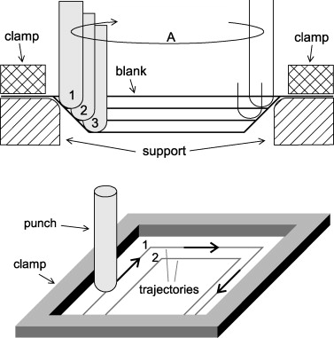
Figure 1: Principle of Single Point Incremental forming, initially realized by Iseki et al. (1989).

1.1.3 Current and Potential Applications for Incremental Forming
Incremental forming’s inherent flexibility and cost-effectiveness make it a pivotal technique for low-volume, high-mix manufacturing, particularly in prototyping, custom component production, and material testing []. By eliminating the need for dedicated molds, incremental forming reduces setup costs and lead times, enabling rapid production and customization across various industries. Its ability to produce complex geometries with high forming limits enables Incremental forming as a solution for applications requiring lightweight, durable components, especially when using advanced materials like Carbon Fiber Reinforced Thermoplastics (CFRTP) [].
The broad applications of incremental forming underscores its potential to transform manufacturing paradigms, particularly for CFRTP components. By enabling the cost-effective production of complex, lightweight parts, the technique supports sustainability goals across various industries, aligning with global trends toward reduced emissions and increased resource efficiency [].

Automotive Industry
In the automotive sector, incremental forming is increasingly adopted for low-volume production of complex, lightweight components, aligning with the industry's shift toward sustainable and efficient manufacturing []. For example, Toyota Motor Corporation utilizes static incremental forming to fabricate the front bumper of the Lexus LC Edge, achieving precise shaping without the use of molds, which reduces production costs by approximately 30% compared to traditional molding for low-volume runs []. The bumper, constructed from discontinuous CFRTP, leverages the high press formability to achieve a smooth surface and dimensional accuracy of ±0.1 mm []. Similarly, Ford utilizes incremental forming for custom interior panels in the Mustang Mach-E electric vehicle, enabling the rapid prototyping of lightweight dashboard components with complex curvatures and reducing the components weight by 15% compared to aluminum alternatives []. Nissan applies the technique for structural components in the Leaf electric vehicle, such as battery enclosure supports, which benefit from CFRTP's vibration absorption and corrosion resistance, enhancing vehicle range by 5% through weight reduction []. These applications demonstrate the incremental forming process’s ability to meet stringent automotive requirements for weight, strength, and cost efficiency.

Figure 2: Incremental Forming Application in Lexus LC Edge Front Bumper [Toyota Motor Corporation, 2020].

Aerospace Industry
In aerospace, incremental forming enables the rapid prototyping and production of lightweight CFRP panels, which are critical for improving fuel efficiency and reducing emissions []. The Airbus A350, which incorporates 53% CFRP by weight, utilizes incremental forming to prototype fuselage panels with complex curvatures, achieving a weight reduction of 20% compared to aluminum counterparts []. The process enables iterative design adjustments without costly mold revisions, thereby reducing development time by up to 40% []. Similarly, Boeing employs incremental forming for winglet components in the 787 Dreamliner, leveraging the technique's high geometric flexibility to produce thin-shell structures with tensile strengths exceeding 1.5 GPa []. The ability to form discontinuous CFRTP panels with minimal spring back (<5%) enhances dimensional accuracy, which is critical for meeting aerospace tolerances of ±0.05 mm []. Incremental forming also supports material testing, enabling engineers to evaluate the fatigue resistance of CFRP under simulated flight conditions, ensuring compliance with International Civil Aviation Organization (ICAO) standards [].

Medical Applications
In the medical field, incremental forming alongside CFRTP, is used in the production of lightweight, high-strength components tailored to patient-specific needs [] such as prosthetic sockets, where the discontinuous CFRTP's strength and low weight reduce wearer fatigue by 10–15% compared to traditional materials, such as acrylic resins []. The process enables rapid customization of socket geometries, achieving a high degree of accuracy with a margin of error of ±0.2 mm ensuring a precise fit []. Additionally, incremental forming is used to produce radiolucent head braces for brain surgery, allowing for precise X-rays to enable precise imaging while maintaining the heads position []. These braces, formed at temperatures of 180–200°C, exhibit smooth surfaces and minimal defects, ensuring patient safety []. The technique's flexibility also supports the prototyping of orthopedic implants, such as bone plates, where CFRTP's corrosion resistance extends implant longevity [].

1.2 NC Machine Tools

1.2.1 Overview
Numerical Control (NC) machines execute automated operations via programmed numerical commands, controlling tool position, speed, and operations with high precision []. Unlike manual processes, NC automation reduces processing times, enhances productivity, and lowers labor costs. Computer Numerical Control (CNC), an advanced form of NC, utilizes computer-based systems for enhanced flexibility and accuracy, making it a prevalent technology in modern manufacturing [9].

1.2.2 NC program, G-Code and Functions
An NC program automates CNC machine operations through blocks of code, such as:
G01 X8 Y10 Z9;
Each block comprises a preparatory function section (e.g., G01 for linear interpolation) a coordinate section (e.g., X8 Y10 Z9 for tool position). Codes that start with the letter “G” serve as preparatory functions, M-codes handle miscellaneous functions (e.g., spindle start/stop), F-codes set feed rates, and S-codes control spindle speed []. Table 2.1 lists the functions used in this research.
Table 1: G-Code Functions for Incremental Forming
G-Code | Positioning | G00
G-Code | Linear Interpolation | G01
G-Code | mm input | G21
G-Code | Absolute coordinate command | G90
G-Code | Relative coordinate command | G91
G-Code | Work coordinate system settings. | G92
M Code | Spindle section | M03
M Code | Program end | M30
F Code | Feed Speed (mm/min) | F1000
S Code | Rotation Speed (RPM) | S500

1.2.3 3D CAD
Computer-Aided Design (CAD) software enables precise digital design of components []. Unlike 2D CAD, 3D CAD, such as Creo Parametric 4.0 used in this study, supports complex geometries and prototyping, reducing production errors by enabling the accurate generation of STL files for toolpath creation []. All test pieces and molds in this research were designed using 3D CAD to ensure precision in incremental forming.
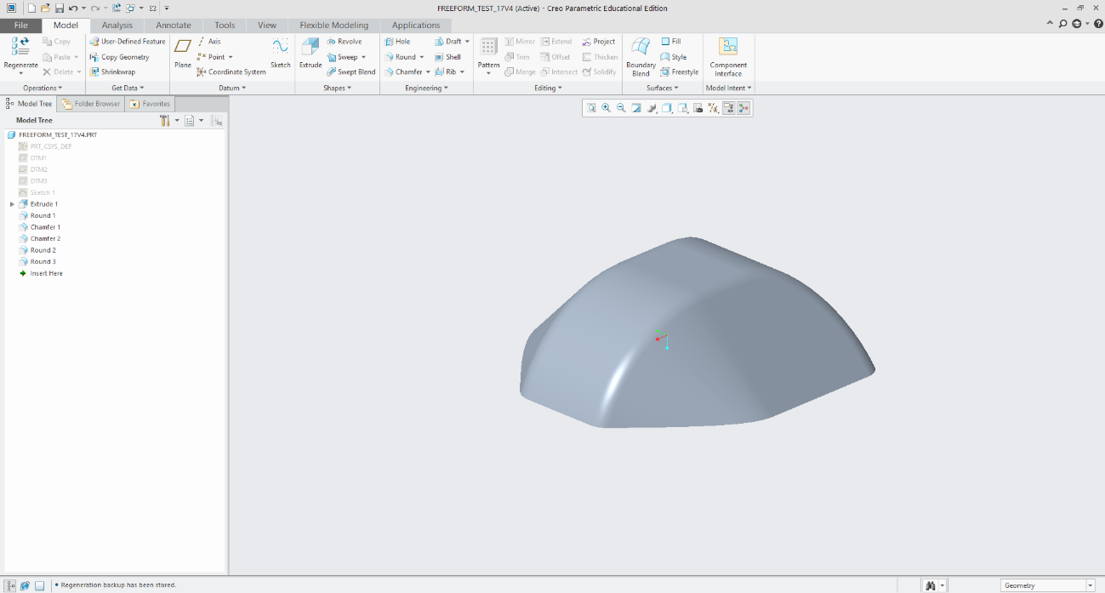
Figure 3: 3D CAD Model of Test Piece Designed in Creo Parametric [Wong, 2025].

1.2.4 CAM
Computer-Aided Manufacturing (CAM) is the use of software and computer-controlled machinery to automate manufacturing. CAM systems are used to generate machining programs for CNC machines, automating the creation of tool paths and reducing manual input errors []. By simulating tool paths, a CAM can prevent forming issues and optimize machining efficiency, significantly lowering production time and costs []. In this study, the CAM system processes STL files from Creo Parametric to produce the NC program for incremental forming.

G90 ; (Absolute positioning)
G21 ; (Set units to millimeters)
G92 X0.0 Y0.0 Z0 ; (Set workpiece origin)
F1000 ; (Set feed rate)
G01 X0.0 Y0.0 Z20 ; (Move to safe height)

Figure 3: Sample NC program for Incremental Forming [Wong, 2025].

1.2.5 Python
Python, an open-source programming language, is renowned for its simplicity and extensive library ecosystem, which enables the efficient development of complex applications []. Libraries such as NumPy, Pandas, and PyVista facilitate mesh processing and data manipulation, making Python ideal for CAM system development. In this study, Python was selected for its readability and ability to process STL files and generate optimized G-code toolpaths for incremental forming.

1.2.6 Toolpath
A tool path is the path along which a machining tool moves. A tool path is created using the 3D coordinates of an STL file from CAD software to collect all the points, forming a point cloud from the triangles of the STL file. From this, the points are sorted, duplicate points are deleted, a set of coordinates is generated, and then the necessary pieces are added to convert the coordinates into the NC program. The NC program can instruct the tool on the machining path. The toolpath was viewed using an NC viewer web browser to identify potential issues before manufacturing.
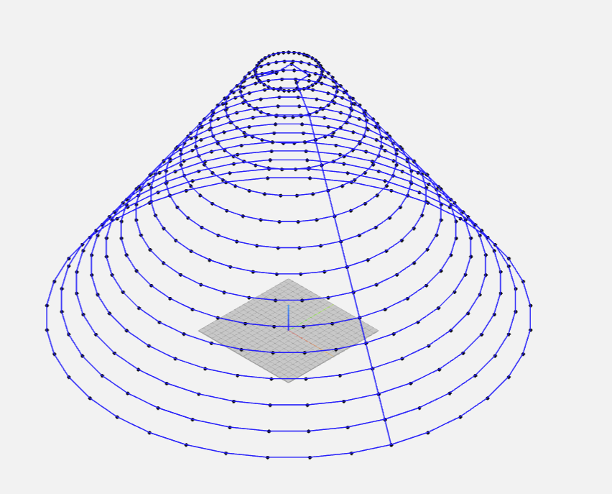
Figure 4: Toolpath Visualization for Truncated Cone [Wong, 2025].

1.3 CFRP (Carbon Fiber Reinforced Plastic)

1.3.1 Overview
Carbon Fiber Reinforced Plastics (CFRP) combine carbon fibers with a polymer matrix to achieve superior mechanical properties, including a specific strength up to 10 times that of iron and a specific gravity of 1.8 g/cm³, which is significantly lower than that of aluminum (2.7 g/cm³) []. CFRP's high strength-to-weight ratio, vibration absorption, and corrosion resistance make it ideal for applications in aerospace, automotive, sports equipment, and medical devices []. Its adoption has surged in industries prioritizing lightweight, durable materials [].

1.3.2 Classification and Characteristics of CFRP
CFRP is categorized by matrix type and fiber orientation, influencing its mechanical properties and applications []. The four main properties are Thermosetting (CFRTS). Thermoplastic (CFRTP), continuous fiber and discontinuous fiber CFRP. CFRTS is characterized by a high specific strength and heat resistance, however, it requires long molding times and is non-recyclable []. CFRTS is used in the aerospace industry and sports equipment. CFRTP offers lower specific strength and heat resistance but enables shorter molding times, lower costs, and partial recyclability []. Continuous Fiber CFRTP features a layered structure with aligned fibers, providing high specific strength but limited formability []. Discontinuous Fiber CFRTP has a random fiber orientation, offering isotropic strength and high press formability, making it ideal for complex shapes despite its lower strength [].
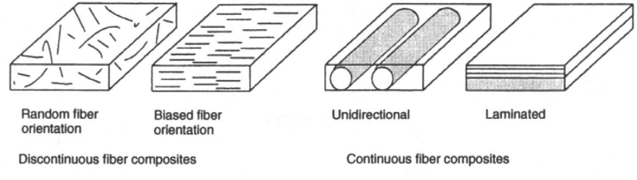
Figure 5: Schematic of Continuous and Discontinuous Fiber CFRP Orientations [Adapted from Tanata, 2023].

1.3.3 CFRP Application Areas
Introduction
Carbon Fiber Reinforced Polymer (CFRP) is a composite material combining carbon fibers with a polymer matrix, typically epoxy, known for its high strength-to-weight ratio, stiffness, and corrosion resistance. Its mechanical properties, such as a tensile strength of 3530 MPa and a tensile modulus of 230 GPa (as seen in Toray’s T300 carbon fiber), make it a preferred material in industries requiring lightweight yet robust solutions. This report explores CFRP’s applications in aerospace, automotive, construction, sports, marine, renewable energy, medical, and industrial sectors, providing technical data to support its use in these fields as of July 7, 2025.
Material Properties
CFRP’s exceptional properties drive its widespread adoption. The following table summarizes key technical specifications for Toray’s T300 carbon fiber, a common component in CFRP composites:
Property | Unit | Nominal Value | Method
Tensile Strength | MPa (kgf/mm²) | 3530 (360) | TY-QA-002
Tensile Modulus | GPa (10³ kgf/mm²) | 230 (23.5) | TY-QA-002
Elongation | % | 1.5 | TY-QA-002
Density | g/cm³ | 1.76 | TY-QA-003
Yield | g/1000m | 1,000: 66; 3,000: 198; 6,000: 396 | TY-QA-004
Specific Heat | Cal/g.°C | 0.19 | -
Electric Resistivity | x 10⁻³ Ω.cm | 1.7 | -
CTE (Coefficient of Thermal Expansion) | 10⁻⁶/°C | -0.41 | -
Thermal Conductivity | Cal/cm.S.°C | 0.025 | -
Filament Diameter | μm | 7 | -
Source: Torayca T300 Technical Data Sheet
These properties, including a density of 1.76 g/cm³ (about one-quarter that of steel), enable CFRP to replace heavier materials like steel and aluminum, reducing weight while maintaining or enhancing strength.
Aerospace Applications
CFRP is integral to aerospace, where weight reduction directly impacts fuel efficiency and performance. The Boeing 787 Dreamliner exemplifies this, incorporating approximately 32,000 kg of CFRP, which constitutes 50% of its primary structure by weight. This results in a 20% weight reduction compared to conventional aluminum designs, contributing to a 20% improvement in fuel efficiency. Components include fuselage sections, wings, tails, and interior parts, with CFRP’s high strength-to-weight ratio (e.g., 3530 MPa tensile strength) ensuring structural integrity under high loads. Similarly, the Airbus A350 uses CFRP for up to 53% of its airframe, reducing maintenance needs. In engine applications, Mitsubishi Chemical’s mid-elasticity-grade carbon fiber in thermoplastic CFRP is used for the PW1100G-JM engine’s structural guide vanes in the Airbus A320neo, achieving a 15% fuel efficiency improvement due to increased fan diameter enabled by CFRP’s lightweight properties.
Sources: Boeing 787 Dreamliner Overview, Mitsubishi Chemical Aircraft Case Study, Boeing 787 from the Ground Up
Automotive Applications
In the automotive industry, CFRP is used to reduce vehicle weight, improving fuel efficiency and performance, particularly in high-performance and electric vehicles. The BMW i3’s Life Module, a CFRP passenger cell, weighs only 150 kg, compared to approximately 250–300 kg for a steel body-in-white of a similar-sized car like the Mini Cooper. This represents a 40–50% weight reduction, offsetting the 250–350 kg weight of the i3’s battery pack, resulting in a curb weight of around 1,300 kg. CFRP’s high torsional rigidity enhances handling and ride comfort. In luxury vehicles like the Porsche 911 S/T, CFRP components such as front wings, bonnet, and doors reduce unsprung mass, improving agility. General estimates suggest CFRP components are 50% lighter than aluminum and over five times lighter than steel, with potential weight reductions of up to 60% when replacing steel parts, leading to a 1g/km reduction in carbon emissions per 10 kg of weight saved.
Sources: BMW i3 Life Module Weight, Porsche 911 S/T Lightweight Construction, Carbon Fiber in Automotive
Construction Applications
CFRP is increasingly used in civil engineering for reinforcing concrete and steel structures, particularly bridges, to enhance load-bearing capacity and extend service life. Experimental studies show significant improvements:
- Shear Strength: Externally bonded CFRP sheets increase shear strength by 10–70% compared to unreinforced concrete.
- Flexural Capacity: External prestressed CFRP tendons boost flexural capacity by up to 70%.
- Ultimate Capacity: CFRP/BFRP composite sheets increase ultimate capacity by 66–75%.
- Crack and Ultimate Moment: Prestressed CFRP plates increase crack moment by 121% and ultimate moment by 103% in reinforced slabs.
- Flexural Capacities with FRP Grids: Under sufficient anchoring, capacities increase by over four times.
For example, the La Canada Bridge in Mexico used Foreva TFC1100 CFRP with a tensile strength of 1,199 MPa and a linear weight of 1,100 g/m² to repair shear and bending cracks. CFRP’s lightweight nature (e.g., density of 1.76 g/cm³) ensures minimal added weight compared to steel reinforcements, which can weigh significantly more.
Sources: Review of Experimental Studies on FRP for Bridge Strengthening, La Canada Bridge Case Study, CFRP in Civil Engineering
Marine Applications
In marine environments, CFRP’s corrosion resistance and strength make it ideal for boat hulls, masts, and booms. For example, CFRP hulls in yachts reduce weight by up to 50% compared to fiberglass, improving speed and fuel efficiency. The low coefficient of thermal expansion (-0.41 x 10⁻⁶/°C) ensures stability in varying temperatures.
Source: Mitsubishi Chemical CFRP Applications
Medical Applications
CFRP’s radiolucency and biocompatibility make it suitable for medical devices like X-ray cassettes and prosthetics. For example, CFRP prosthetic limbs are 30–50% lighter than metal alternatives, improving patient mobility. The material’s high strength (3530 MPa) ensures durability under repetitive loading.
Source: Toray CFRP Applications
Conclusion
CFRP’s applications span aerospace, automotive, construction, sports, marine, renewable energy, medical, and industrial sectors, driven by its superior mechanical properties. Technical data, such as a 20% weight reduction in the Boeing 787, a 150 kg Life Module in the BMW i3, and up to 70% increases in bridge load capacity, highlight its transformative impact. As research and manufacturing advancements continue, CFRP’s role in engineering is set to expand, balancing performance with cost and sustainability considerations.

1.3.4 CFRP Sample Used in This Study
This study utilizes discontinuous fiber CFRTP due to its short molding time, cost-effectiveness, and partial recyclability, making it suitable for incremental forming of complex, low-volume components, aligning with the research’s focus on efficient toolpath generation.

1.4 Previous Research A

1.4.1 Overview
In this previous research, the researcher developed a Python-based CAM system for static incremental forming of discontinuous fiber CFRTP, utilizing an oil bath for material heating to enable dieless forming. The system generates NC program toolpaths from CAD models, addressing the high costs and inflexibility of traditional molding for low-volume, thin-shell components [].

1.4.2 CAM System and Design of the Test Shape
The CAM system achieves three goals: read an STL files from Creo Parametric 4.0, extract the 3D point clouds of the target shapes, and create a tool path in G-code. The code utilizes Python libraries, to generate a point cloud from the STL file. It converts the clouds into layers by Z-height and connects the points in each layer by the minimum Euclidean distance. Finally, it takes the coordinates and adds the proper syntax for use by the CNC machines. The shape created in Creo was a truncated cone with varying dimensions. The radius of the shape ranges from 20 mm to 40 mm, and similarly, the wall angle is 30°, 40°, and 50°. The pitch or resolution of the STL is 1. The dimensions were selected to match the working area and limitations of the experimental setup. The shape was chosen because it is suitable for proof of concept, especially for plastic deformation layering.

1.4.3 Experimental Equipment
The experimental setup from this research is summarized in Table 2.2, with most equipment reused in this study for consistency.
Table 2: Experimental Equipment Specifications
Equipment | Description | Specification
CFRTP Sheet | PA6 matrix, 20 wt% carbon fiber | 110 mm × 110 mm × 1 mm
Oil Bath | T-22H (Thomas Scientific) | Up to 200°C, ±0.2°C precision, jet circulation
Silicone Oil | KF968 (Shin-Etsu) | Non-volatile, stable to 250°C, fire-resistant
CNC Machine | Sodick MC430L | X 420 mm, Y 350 mm, Z 200 mm, feed up to 36 m/min
Tool (Mandrel) | SUS304 | 5 mm diameter, 2.5 mm radius tip, 60 mm length
Jig | Custom design | Submerged in oil bath, secure clamping, detachable

1.4.4 Results
The experiments identified key parameters that influence the success of incremental forming, including material temperature, tool rotation, wall angle, and radius [5].
Temperature Effects
Optimal forming occurred at 180–200°C (453–473 K), achieving smooth surfaces and minimal defects. Below 160°C (433 K), insufficient softening led to cracks, with a minimum forming temperature of 50°C (323 K) [5].
Tool Rotation
A spindle speed of 1000 rpm enhanced forming depth (up to 14.9 mm) and surface smoothness (Ra < 2 µm), reducing uneven wall thickness compared to non-rotating conditions [5].
Wall Angle
Wall angles of 30° and 40° yielded smooth forming with minimal springback (< 5%). Angles near 40° exhibited minor deformations, while angles greater than or equal to 50° were at risk of cracking due to excessive stress [5].
Radius Variations
Smaller radii (20 mm) achieved deeper forming (14.9 mm) but increased wall stress (up to 300 MPa), while larger radii (40 mm) produced shallower forms (8 mm) with uniform wall strength [5].
Table 3: Forming Criteria Summary
Condition | Depth (mm) | Temperature (°C) | Radius (mm) | Wall Angle (°) | Spindle Speed (rpm)
Maximum | 14.9 | 200 | 20 | 40 | 1000
Minimum | 3.6 | 160 | 40 | 50 | 0

1.4.5 Conclusions
The previous research [5] developed a Python-based CAM system that effectively generated toolpaths from STL data to be used in static incremental forming of discontinuous CFRTP. By leveraging Python libraries such as PyVista, Pandas, and NumPy, the CAM system extracted a 3D point clouds, sorted them by Z-height, and connected points using a nearest-neighbor algorithm, enabling flexible production of complex shapes for low-volume applications []. This approach of making a toolpath allows the CAM system to be compatible with any CAD software that produces STL files. However, the CAM system itself has several limitation, preventing it from handling complex geometries and is susceptible to toolpath errors such as creating a “messy “ toolpath that moves the tool to unnecessary points.
During the incremental forming experiments, it was found that at wall angles of 50° or greater had a higher chance of breaking the test piece. The author of previous research A highlighted some challenges for future experiments namely the issue of springback shape distortion and the need for advanced evaluation methods, suggesting that including scribed circle tests and 3D scanning with Einscan-SE might help with analyzing the formed shape.

1.5 Current Research Objectives
This study aims to improve the CAM system from the previous research which can be found in the appendix. The main areas of the CAM system that will be focused on is in the CAM systems ability to produce precise, error-free toolpaths in the static incremental forming of discontinuous CFRTP for more complex geometries, the speed at which the program can output the toolpath, and to streamline the process from design to manufacturing. To evaluate the CAM system’s ability to generate an error free toolpath, the toolpath’s performance will be first presented in NC viewer to confirm a clean toolpath and then tested by using a Sodick MC430L CNC machining center in controlled heating conditions using an oil bath at 120°C. The research will use the CAM system in previous research as a baseline for the new complex test shape which will be shown later in the paper.

Chapter 2: Toolpath Generation

2.1 Program Overview
This chapter will describe the changes and overall flow of the updated CAM system based on the previous research to allow the system to support complex geometries. The updated CAM system’s overall workflow is similar to the previous CAM system, it takes the STL data from a CAD software, generates a toolpath, and converts them to G-code for CNC machining. The updated workflow introduces a step where all the logic for making the toolpath is done. The entire CAM system can be found in the Code A1 section of the appendix.
Figure 6: CAM System Workflow for Toolpath Generation [Wong, 2025].

2.2 Libraries and Variables

Libraries
Python libraries are collections of pre-written code that provide reusable functions and tools to simplify programming tasks. Libraries help optimize code that is used for computational problem-solving, simulations, and optimization [Guttag]. Python offers an extensive library and the ability for third-party programmers to create libraries and are made available to the public.
The updated CAM system uses several libraries to optimize the toolpath’s generation.
- Pandas: This library is primarily utilized for data manipulation and storage. Pandas provides the `DataFrame` structure which can store the point cloud data that is extracted from STL files. Its ability to manage large datasets efficiently is crucial for processing the hundreds of thousands of points typically generated from 3D models [3].
- NumPy: Numpy is able to do high-performance numerical operations, including array manipulations and linear algebra functions. NumPy’s efficiency is vital for handling the computational demands of toolpath generation as it is able to calculate the distances between the points [3].
- SciPy (ConvexHull): The `ConvexHull` module from SciPy computes the convex hull of 2D point sets. It identifies the outermost points of each layer to define the toolpath boundary [3]. The function of the library ensures that only the external contour of the shape is machined, reducing unnecessary tool movements.
- STL (numpy-stl): The `mesh` module from the `numpy-stl` library reads STL files, extracting the points coordinates to form the point cloud used for toolpath generation [7]. STL files are standard in CAD systems for representing 3D geometries as triangular meshes.

Variables
The previous CAM system also had variables. However, their primary function was to store values for the toolpath generation. In the updated CAM system, there were several variables that were added so that the operator can simply adjust the values depending on the shape that they are creating. The following variables are the variables that are important to change depending on the test shape.
- TOOL_DIAMETER: The tool diameter variable changes depending on the diameter of the forming tool. This parameter is used to calculate the offsets, ensuring the tool’s geometry is accounted for during forming [5].
- Z_SPRINGBACK_OFFSET: When conducing incremental forming without a mold, the material often rebounds slightly. This phenomenon is called springback [12]. This variable attempt to compensate for material springback. This variable is typically a negative value so that the Z-coordinates are adjusted to press deeper, ensuring shape fidelity.
- LAYER_THICKNESS: During the machining process, it is important to have uniform layer distances. While no direct correlation was shown to if uniform layer distances will improve formability of the formed shape, this variable defines the vertical distance between layers, controlling the resolution of the toolpath along the Z-axis. Uniform layer spacing ensures consistent forming depth [5].
- MIN_DISTANCE: The minimum distance variable is used to prevent clusters of points from forming along the toolpath. This ensures that the toolpath is smooth and prevents unnecessary tool movements.
- Z_OFFSET: This offset adjusts the Z-coordinate of the entire toolpath to align with the CNC machine’s workspace, ensuring the tool operates within the safe working area [9].
- SAFE_Z_RELATIVE: This variable specifies the height to which the tool retracts after forming, preventing collisions during tool withdrawal that might damage the machined shape [9].

2.3 Modules
Majority of the changes that were made to the CAM system can be found in the setup of variables, libraries and logic section of figure 6. In that section, the code can be broken down into several subsections or modules. The modules are done in this way so that the points are in a refined state before being run through the main toolpath loop or setup the logic to be used in the main toolpath loop.

Loading STL File and Extracting Point Cloud
def load_stl_to_dataframe(stl_file, layer_thickness=1.0):
stl_mesh = mesh.Mesh.from_file(stl_file)
vertices = stl_mesh.vectors.reshape(-1, 3)
df = pd.DataFrame(vertices, columns=['x', 'y', 'z'])
df = df.drop_duplicates().reset_index(drop=True)
df['z'] = np.round(df['z'] / layer_thickness) * layer_thickness
return df.dropna()
Figure X: Code to load a STL and create a point cloud.
This module reads the STL file and converts the vertices of the triangles from the STL file into a structured point cloud, assigning the values into cartesian coordinate points (X, Y, and Z), for toolpath generation. The module then edits the point cloud to ensure that the layers that are grouped by the Z coordinate, are equidistant to each other. The code does this by rounding the Z coordinate value to the nearest multiple of the layer thickness that was set earlier. The module then removes duplicate points and incomplete coordinates to enhance computational efficiency and toolpath accuracy which is key when processing complex geometries [5]. Then the points are saved into a data frame to be used later.

Filtering Close Points to Prevent Clustering
def filter_close_points(points, min_distance=0.5):
filtered = [points[0]]
for p in points[1:]:
if np.linalg.norm(p - filtered[-1]) >= min_distance:
filtered.append(p)
return np.array(filtered)
Figure X: Code for Preventing Point Clustering on the Toolpath
This module sets up some logic to be used in the main toolpath generation loop. The module reduces the point density in the point cloud to remove clusters of points, which could lead to inefficient toolpaths or machining errors. The module does this by loading the points that were outputted from the previous module and calculating the distance from the initial point in the list of points and if the distance exceeds the min_distance value, the point is removed from the list. The filtered points are returned as a NumPy array, preserving only points that are spaced apart. By enforcing a minimum distance, this function optimizes the toolpath, reducing machining time while also reducing errors.

Sorting Points to Prevent Doubling Back
def sort_points_no_overlap(points):
center = points.mean(axis=0)
angles = np.arctan2(points[:, 1] - center[1], points[:, 0] - center[0])
sorted_indices = np.argsort(angles)
sorted_points = points[sorted_indices]
n = len(sorted_points)
for i in range(n):
p1, p2 = sorted_points[i], sorted_points[(i + 1) % n]
for j in range(i + 2, n):
p3, p4 = sorted_points[j], sorted_points[(j + 1) % n]
if intersects(p1, p2, p3, p4):
sorted_points[i + 1:j + 1] = sorted_points[i + 1:j + 1][::-1]
return sorted_points
Figure X: The Code for Sorting Points to Prevent Doubling Back in the Toolpath

def intersects(p1, p2, p3, p4):
def ccw(A, B, C):
return (C[1] - A[1]) * (B[0] - A[0]) > (B[1] - A[1]) * (C[0] - A[0])
return ccw(p1, p3, p4) != ccw(p2, p3, p4) and ccw(p1, p2, p3) != ccw(p1, p2, p4)
Figure X: Line Segment Intersection Check
This module sorts points in each layer to create a non-overlapping, clockwise toolpath, minimizing travel distance and preventing toolpath intersections. The module calculates the mean of the points and determines the layer’s centroid. The layers centroid then serves as a reference for the calculation of the angles of each point, then the module sorts the points by these angles, reversing the order of points if there are any intersections between the lines it temporarily creates to prevent doubling back.
The sorting algorithm, inspired by a simplified Traveling Salesperson Problem (TSP) approach, ensures an efficient and non-overlapping toolpath, which is critical for smooth CNC operation and high-quality surface finishes [3]. By preventing doubling back, it reduces machining time and mitigates risks of toolpath errors, aligning with the research's goal of optimizing toolpath generation for complex CFRTP shapes [5].

Smoothing Hull Points
def smooth_hull_points(points, alpha=0.3):
smoothed = points.copy()
for i in range(len(points)):
prev = points[(i - 1) % len(points)]
next = points[(i + 1) % len(points)]
smoothed[i] = (1 - alpha) * points[i] + alpha * (prev + next) / 2
return smoothed
Figure X: Smoothing of the Toolpath
To ensure that the machining process is smooth, this module is applied to the points that go through the convex hull function and the reverse offset module, reducing sharp transitions and improving toolpath continuity. The module creates a copy of the input points then a weighted average is computed using the current point and the average of the neighboring points. The `alpha` parameter controls the smoothing intensity, balancing the original point's position with the influence of its neighbors. Then the module ensures that the points are continuous and finally returns the points to the toolpath.
Sharp transitions in the toolpath can cause abrupt tool movements, leading to fractures in the material or tool vibrations. The smoothing module enhances the toolpath quality, ensuring uniform deformation.

Applying Reverse Offset
def reverse_offset(points, TOOL_DIAMETER=2.5, z_springback_offset=-0.1):
adjusted_points = points.copy()
center = points[:, :2].mean(axis=0)
distances = np.linalg.norm(points[:, :2] - center, axis=1)
layer_radius = distances.max() if distances.size > 0 else 1.0
print(f"Layer at Z={points[0, 2]:.2f}, points={len(points)}, radius={layer_radius:.2f} mm, TOOL_DIAMETER={TOOL_DIAMETER:.2f} mm")
for i, point in enumerate(adjusted_points):
direction = point[:2] - center
norm = np.linalg.norm(direction)
if norm > 1e-6:
direction /= norm
offset = TOOL_DIAMETER * direction
adjusted_points[i, :2] -= offset
print(f"Point {i}: Offset applied = {offset[0]:.2f}, {offset[1]:.2f}")
adjusted_points[i, 2] += z_springback_offset
adjusted_points[:, :2] = smooth_hull_points(adjusted_points[:, :2])
x_min, x_max = adjusted_points[:, 0].min(), adjusted_points[:, 0].max()
y_min, y_max = adjusted_points[:, 1].min(), adjusted_points[:, 1].max()
adj_distances = np.linalg.norm(adjusted_points[:, :2] - center, axis=1)
adj_layer_radius = adj_distances.max() if adj_distances.size > 0 else 1.0
print(f"Adjusted radius={adj_layer_radius:.2f} mm")
print(f"Bounding box: X=[{x_min:.2f}, {x_max:.2f}], Y=[{y_min:.2f}, {y_max:.2f}]")
return adjusted_points
Figure X: Reverse Offset Logic
The reverse offset module adjusts the toolpath to account for the tool’s geometry and material springback, ensuring accurate forming. During this process, the centroid of each layer is calculated from the points that are being processed in the main toolpath generation loop, defining the layers shape. Then the tool diameter and z_springback_offset values are applied to the points on the toolpath to ensure that the machined shape is accurate. Finally, the adjusted 3D points are returned, incorporating the offset and smoothing.

2.4 Toolpath Generation Process

Main Toolpath Generation Loop
ll = []
prev_exit_point = None
z_levels = sorted(df['z'].unique(), reverse=True)
if len(z_levels) > 1:
z_diffs = [z_levels[i] - z_levels[i + 1] for i in range(len(z_levels) - 1)]
avg_spacing = np.mean(z_diffs)
print(f"Average layer spacing in input data: {avg_spacing:.3f} mm")
else:
avg_spacing = 1
print("Only one Z level in input data, using default spacing of 1 mm")
uniform_z_levels = []
start_z = z_levels[0]
for i in range(len(z_levels)):
new_z = start_z - i * avg_spacing
uniform_z_levels.append(new_z)
center_x, center_y = None, None
for layer_idx, current_layer_z in enumerate(z_levels):
current_layer = df[df['z'] == current_layer_z][['x', 'y', 'z']].values
if len(current_layer) >= 5:
center_x, center_y = current_layer[:, :2].mean(axis=0)
break
if center_x is None or center_y is None:
print("Warning: Could not compute center from any layer. Using (0, 0) as fallback.")
center_x, center_y = 0.0, 0.0
for layer_idx, current_layer_z in enumerate(z_levels):
current_layer = df[df['z'] == current_layer_z][['x', 'y', 'z']].values
if len(current_layer) < 5:
print(f"Skipping layer at Z={current_layer_z:.2f} due to insufficient points ({len(current_layer)})")
continue
layer_points_2d = current_layer[:, :2]
try:
hull = ConvexHull(layer_points_2d)
hull_coords = layer_points_2d[hull.vertices]
except Exception as e:
print(f"Skipping layer at Z={current_layer_z:.2f} due to hull error: {str(e)})")
continue
if hull_coords.shape[0] < 5:
print(f"Skipping layer at Z={current_layer_z:.6f} due to insufficient hull vertices ({hull_coords.shape[0]})")
continue
hull_coords = filter_close_points(hull_coords, min_distance=MIN_DISTANCE)
hull_z = np.full((hull_coords.shape[0], 1), uniform_z_levels[layer_idx])
hull_points_3d = np.hstack([hull_coords, hull_z])
adjusted_points_3d = reverse_offset(hull_points_3d, TOOL_DIAMETER=TOOL_DIAMETER, z_springback_offset=Z_SPRINGBACK_OFFSET)
adjusted_points_2d = adjusted_points_3d[:, :2]
sorted_points = sort_points_no_overlap(adjusted_points_2d)
if layer_idx == 0:
centroid = np.array([center_x, center_y])
dists = np.linalg.norm(sorted_points - centroid, axis=1)
start_idx = np.argmin(dists)
sorted_points = np.roll(sorted_points, -start_idx, axis=0)
elif prev_exit_point is not None:
dists = np.linalg.norm(sorted_points - prev_exit_point[:2], axis=1)
start_idx = np.argmin(dists)
sorted_points = np.roll(sorted_points, -start_idx, axis=0)
sorted_layer = np.hstack([sorted_points, np.full((sorted_points.shape[0], 1), adjusted_points_3d[0, 2])])
layer_path = list(sorted_layer)
layer_path.append(layer_path[0]) # Close the loop
ll.extend(layer_path)
prev_exit_point = layer_path[0]
if len(ll) == 0:
print("Warning: No toolpath points generated. Check input data or layer filtering.")
exit()
Figure X: The Code for the Main Toolpath generation loop
The main loop integrates all previous functions to create a cohesive toolpath to later convert to G-code. The loop processes the point cloud by every Z-level or layer of the STL file to create a continuous toolpath. The loop starts by creating an empty list where the toolpath will be put after the toolpath is generated from the coordinates.
The loop will also keep track of the last point for smooth layer transitions and closing the layer. For the first layer in the shape, the point closest to the centroid is selected as the starting point and for the following layers the point that is the closest to the last point of the previous layer is chosen. The loop starts processing the layers from top to bottom, mimicking the incremental forming process [2]. The loop then also calculates the centroid for the first layer with 5 points to ensure sufficient data for convex hull computation. Next, convexhull identifies the outermost points of the 2D layer, defining the layer for machining [3]. After convexhull is applied, all the modules previously discussed except for the STL loading and point cloud formation are applied to the list.
Finally, the loop stores the processed layer in the list that it created in the beginning of the process and the last point in the list is set as the first point for the next layer.
The use of uniform Z-levels and convex hulls ensures compatibility with CNC machining. At the same time, the selection of nearest-neighbor start points optimizes tool travel, reducing machining time and enhancing efficiency [3]. The robust error handling aligns with the research's emphasis on error-free toolpaths [2].

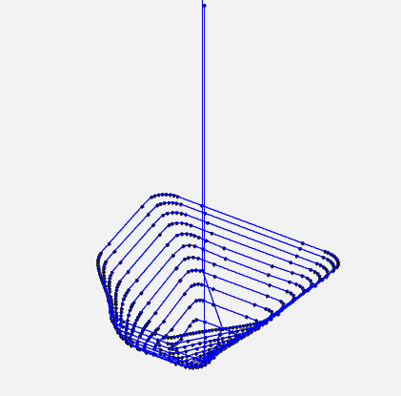
Figure 7: Toolpath Generation for Complex Shape [Wong, 2025].

2.6 G-Code Generation and Export
ll = np.array(ll)
ll[:, 2] -= Z_OFFSET
ll = np.round(ll, 2)
pd.DataFrame(ll, columns=['x', 'y', 'z']).to_csv('toolpath.csv', index=False)
df_ltp = pd.read_csv('toolpath.csv')
df_ltp['x'] = df_ltp['x'].round(2)
df_ltp['y'] = df_ltp['y'].round(2)
df_ltp['z'] = df_ltp['z'].round(2)
df_gchord = pd.DataFrame({
'G': 'G01',
'x': 'X' + df_ltp['x'].map('{:.2f}'.format),
'y': 'Y' + df_ltp['y'].map('{:.2f}'.format),
'z': 'Z' + df_ltp['z'].map('{:.2f}'.format),
'EOB': ';'
})
first_x = round(df_ltp.iloc[0]['x'], 2)
first_y = round(df_ltp.iloc[0]['y'], 2)
first_z = round(df_ltp.iloc[0]['z'], 2)
gcode_header = [
"G90 ; (Absolute positioning)",
"G21 ; (Set units to millimeters)",
"M03 ; (Start spindle)",
"S500 ; (Setting spindle speed)",
"F1000 ; (Set feedrate)",
f"G00 X{center_x:.2f} Y{center_y:.2f} ; (Rapid move to centroid)",
f "G01 Z{first_z:.2f} ; (Drop to first point's Z)",
f"G01 X{first_x:.2f} Y{first_y:.2f} ; (Move to first toolpath point)"
]
last_x = round(df_ltp.iloc[-1]['x'], 2)
last_y = round(df_ltp.iloc[-1]['y'], 2)
last_z = df_ltp.iloc[-1]['z']
final_safe_z = last_z + SAFE_Z_RELATIVE
gcode_footer = [
f"G01 X{last_x:.2f} Y{last_y:.2f} Z{final_safe_z:.2f} ; (Retract tool to safe Z)",
"M30 ; (End of program)"
]
with open('Gchord.txt', 'w') as f:
for line in gcode_header:
f.write(line + '\n')
df_gchord.to_csv(f, index=False, sep=" ", header=False, mode='a')
for line in gcode_footer:
f.write(line + '\n')
Figure X: Coordinate points to G-code conversion
This final section of the code converts the coordinate points into the toolpath by applying the G-code functions and exports it for CNC machining. First, the Z-coordinates are adjusted by subtracting the value of the Z_OFFSET variable to align the toolpath with the CNC machine’s workspace. The values are then rounded by two decimal places to increase the precision of the toolpath. The list of coordinates is saved as a CSV file (`toolpath.csv`) for storage. A DataFrame is created with G-code commands, prefixed coordinates (`X,` `Y,` `Z`), and semicolons (`;`) as end-of-block markers are then combined with the coordinates to generate the toolpath.
After this, a header and footer are added to the toolpath with the G-code annotations ready for use in the CNC machine. The header and footer can be seen in figure X and figure X respectively. The G-code conversion ensures compatibility with CNC machines, enabling automated incremental forming [9]. The header and footer streamline machine setup and shutdown, while the centroid-based initial move optimizes tool positioning, reducing setup time. The G-code conversion enables the improvement of the design-to-manufacturing process.[2].
G90: Sets absolute positioning.
G21: Uses millimeters as units.
M03: Starts the spindle.
S500: Sets spindle speed to 500 rpm, optimized for CFRTP forming [5].
F1000: Sets feed rate to 1000 mm/min.
f"G00 X{center_x:.2f} Y{center_y:.2f} ; (Rapid move to centroid)",
f"G01 Z{first_z:.2f} ; (Drop to first point's Z)",
f"G01 X{first_x:.2f} Y{first_y:.2f} ; (Move to first toolpath point)"
Figure X: G-code Header
f"G01 X{last_x:.2f} Y{last_y:.2f} Z{final_safe_z:.2f} ; (Retract tool to safe Z)",
"M30 ; (End of program)"
Figure X: G-code Footer

Finally the file is exported to a text file titled `Gchord.txt` for direct CNC input.

2.7 NC Viewer Confirmation
To validate that there are no issues with the toolpath, the website, NCviewer.com is used to visualizes the toolpath and simulate the forming process. This extra step enables the operator to identify and address any potential issues that may arise before the manufacturing process begins.
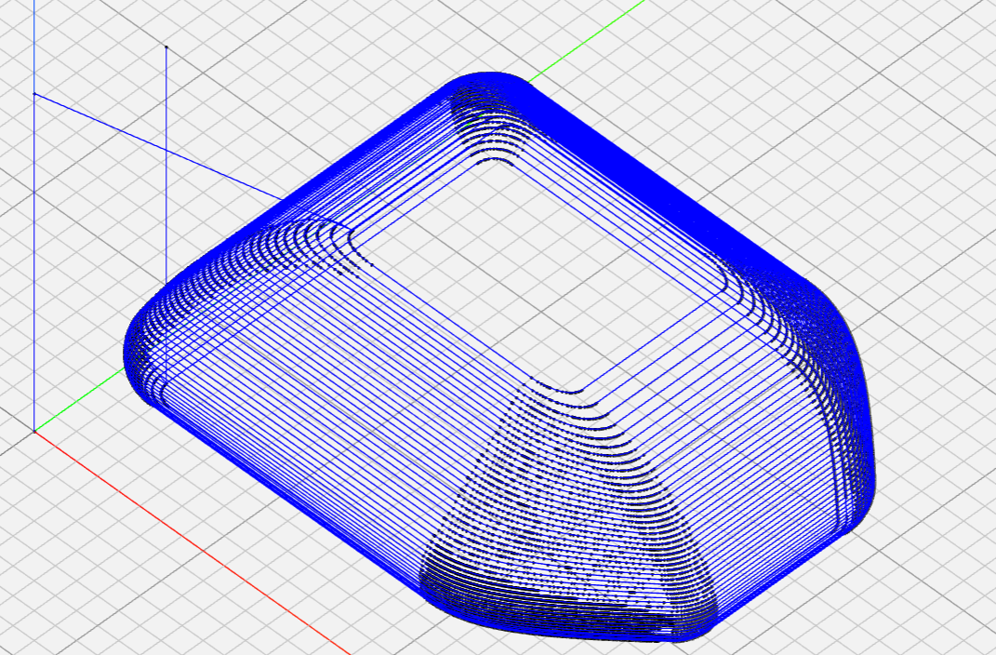
Figure 8. NC Toolpath Visualization [Wong, 2025].

Chapter 3: Incremental Forming Experiment and Evaluation

3.1 Introduction
As mentioned in Section 1.5 of this research paper, this study aims to improve the CAM system based on previous research, which can be found in the appendix. The main areas of focus for the CAM system are its ability to produce precise, error-free toolpaths for the incremental forming of discontinuous CFRTP with more complex geometries, the speed at which the program can output the toolpath and streamlining the process from design to manufacturing. To evaluate the CAM system’s ability to generate an error-free toolpath, the toolpath generated by the CAM system will be used on nylon sheets and discontinuous CFRTP.

Experimental Equipment
Much of the equipment used in this experiment will be the same as that used in previous research (A) and is summarized in Table 3.1, bellow.
Table 3.1: Experimental Equipment Specifications
Equipment | Description | Specificaton
CFRTP Sheet | PA6 matrix, 20 wt% carbon fiber | 110 mm × 110 mm × 1 mm, dried at 120°C for 24 h (ETTAS oven)
Oil Bath | T-22H (Thomas Scientific) | Up to 200°C, ±0.2°C precision, jet circulation
Silicone Oil | KF968 (Shin-Etsu) | Non-volatile, stable to 250°C, fire-resistant
CNC Machine | Sodick MC430L | X 420 mm, Y 350 mm, Z 200 mm, feed up to 36 m/min
Tool (Mandrel) | SUS304 | 5 mm diameter, 2.5 mm radius tip, 60 mm length
Jig | Custom design | Submerged in oil bath, secure clamping, detachable

Machining Center
The Sodick MC430L is a vertical precision linear machining center. The machining center can read the G-code toolpaths used in the tests. The machining center can move in three directions, X, Y, and Z, and features a tool clamp attached to the Z axis. The maximum travel distance of the machining center is 420 mm in the X direction, 350 mm in the Y direction, and 200 mm in the Z direction. The maximum federate or maximum speed that the machine center can move is 36 m/min, and the maximum spindle speed of 40,000 rpm.
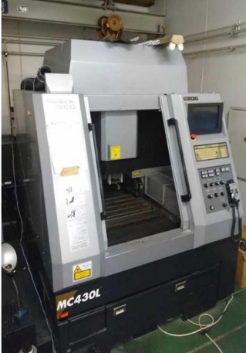
Figure 9: Appearance of MC430L

Discontinuous CFRTP
Discontinuous CFRTP (PA6 matrix, 20 wt% carbon fiber, 110 mm × 110 mm × 1 mm) was chosen for its isotropic strength, high press formability, and cost-effectiveness [12].

Oil Bath
The T-22H oil bath (Thomas Scientific) provides uniform heating up to 200°C with a precision of ±0.2°C. The oil bath is secured in the machining center to ensure the CFRTP is soft during forming.
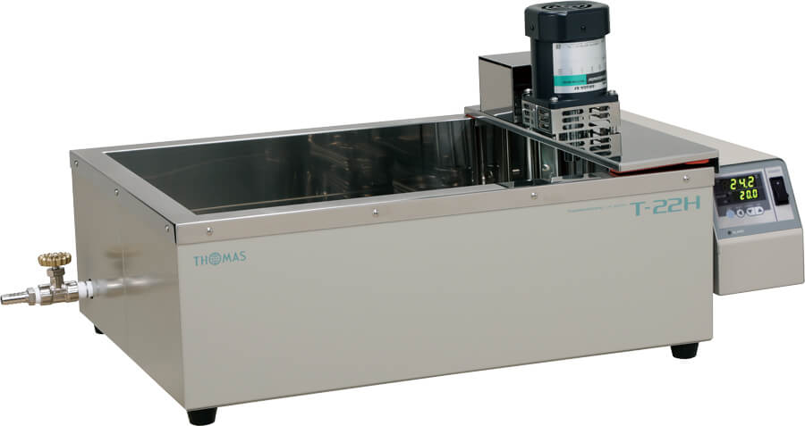
Figure 10: Appearance of T-22H [Wong, 2025]

Type of Oil
The oil that was used to heat the CFRTP up is the Shin-Etsu KF968 silicone oil due to its ability to retain a high temperature of up to 250°C. This is important as during the tests, the temperatures that the tests with CFRTP are done at are at 150, well below the 250°C. Alongside temperature resistance, its low volatility, and fire resistance are factors to why the oil was selected as it ensures safety and stability at temperatures ranging from 50 °C to 200°C (323–473 K) [5].


Figure 11: Shin-Etsu Chemical KF968 oil that is used. [Author, 2025]

Forming tool
A SUS304 mandrel (5 mm diameter, 2.5 mm radius tip, 60 mm length) was used as the forming tip for the experiments. The mandrel was secured to the machining center by a Mega Micro Type S Chuck. The Chuck allows the forming tool to remain steady even when rotated at a high speed allowing incremental forming to be done at a high rotations per minute.
Table X: Mega Micro Type S Chuck Dimensions
Mega Micro type S Chuck
Ød : | 0.45 - 6.05
ØD: | 14 mm
L: | 45
L1: | 32
G: | -
H1: | 28
H2: | 31
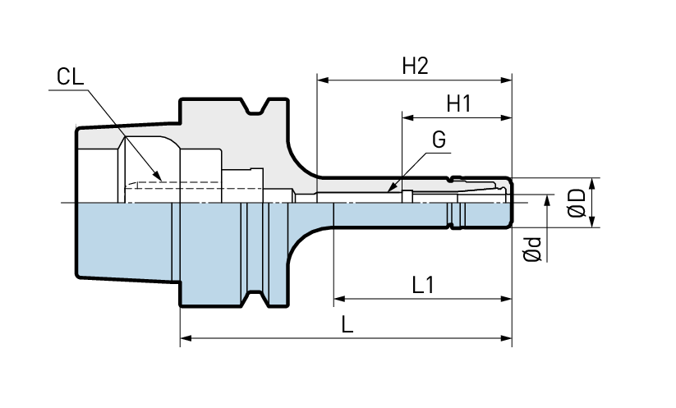
Figure 12: Mega Micro Type S Chuck Without the Tool

Aluminum and Carbon Fiber mold’s
A 3D-printed mold that was printed with a Markforged II 3D printer was used to test the feasibility of the CAM system’s generated toolpath using a nylon sheet before the tests with CFRTP could be conducted. The nylon sheet was chosen as it has similar properties to the CFRTP and was a less expensive material to test the toolpath. The Aluminum mold was used for experiments with the CFRTP due to its ability to withstand the high temperatures that would get the CFRTP into a malleable state.
Both the aluminum and carbon fiber molds are 89.92 mm x 89.92 mm x 20 mm thick as seen in the technical drawing in the figure below.
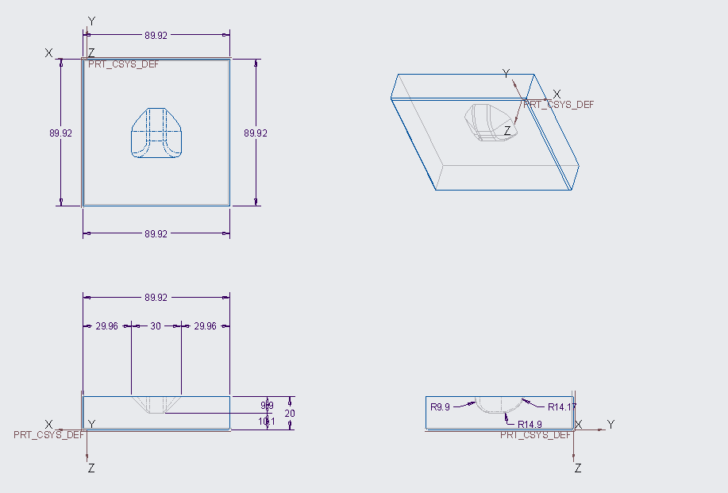
Figure X: Isometric Drawing of the Molds used in the Experiment

Jig Dimensions
A custom jig was used to secure the CFRTP in place during incremental forming. The jig is 190 mm x 190 mm x ___ mm with a 90 mm x 90 mm square located in the middle of the jig. This is to allow for a mold to be placed in the center if there is a need. The Jig also has a removable upper frame that secures CFRTP sheets during the forming process. The jig can be used with or without a mold and with or without oil as shown in the figures bellow.
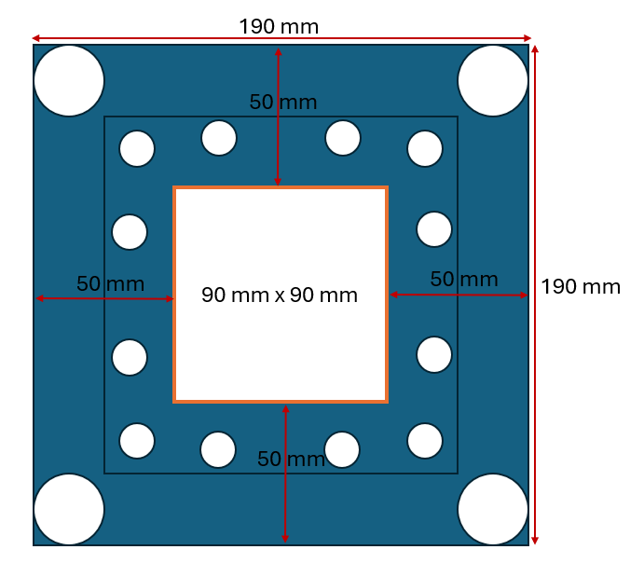
Figure 13: Jig dimensions [Wong, 2025]
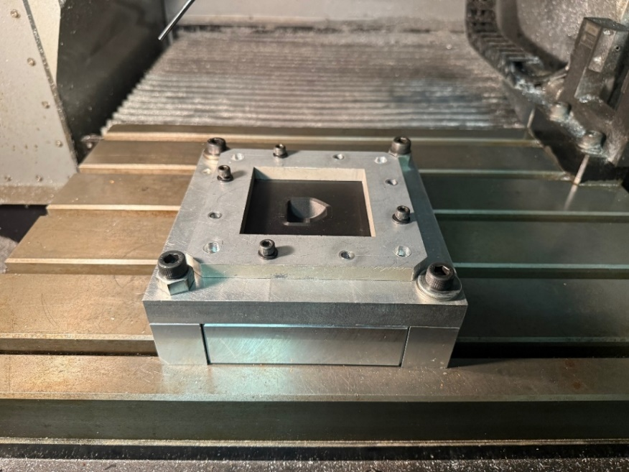
Figure 14: Jig Arrangement Outside of the Oil Bath [Wong, 2025]

Figure 15: Jig Arrangement Inside an Oil Bath Configuration (Wong, 2025 )

Test shape
To test the limits of the CAM system, the following test shape was run through the CAM system. This shape was selected as the test shape due to its greater complexity compared to the test shape used in previous research, as well as the constraints of the test materials, the physical limitations of the machining center, the machining tool, and the constraints of the type of incremental forming that is being conducted in this research.

Figure X: Test Shape Used in the Experiment (Wong, 2025 )

Experimental Setup and Procedure
Two different processes with and without a mold
Process of conducting one incremental forming experiment with the mold:
Mold inside the jig-> secure the workpiece to jig -> run the G-code -> wait for the program to complete -> move the tool to a safe height so that it does not become damaged when removing the test piece -> remove the test piece -> repeat.

Process of conducting one incremental forming experiment without the mold:
Increase the height of the jig (so that the machining center can reach the required depth) -> secure the workpiece to the jig -> run the G-code -> wait for the program to complete -> move the tool to a safe height so that it does not become damaged when removing the test piece -> remove the test piece -> repeat.

To test the toolpath generated by the CAM system, the test shape was designed in Creo 9.0 parametric and exported as an STL file. The experimental equipment described in the previous section was used. The toolpath was generated by uploading the text file to a computer that is connected to the machining center via an Ethernet cable. The toolpath is then loaded on the machining center and used during the experiment.
The oil bath is secured to the machining center, with the jig attached to the bottom of the oil bath, as shown in Figure X. Depending on the testing conditions in the experiments, the mold is inserted into the jig, and the nylon sheet or CFRTP is secured to the jig by the upper plate. After this, the temperature is set, and two of the four tests were completed at 120°C, while the other two were completed at 150°C. After the temperature reaches the target temperature, the toolpath can be executed to machine the test shape.
The initial setup of the machining center, before experimenting, will be described in the appendix, as it is not relevant to the following process.

3.4 Experimental Results

CAM System Comparison
When comparing the updated CAM system with the previous research’s CAM system for a complex shape, the updated CAM system is more effective at handling complex shapes. The figures below show a comparison of the previous CAM system's toolpath and the updated CAM system's toolpath for the updated test shape. The previous CAM system’s toolpath contains numerous extra points, which slow down the creation of the toolpath and the machining process.
The updated CAM system creates the toolpath with only the necessary points, optimizing both the shape detail and the time required to generate the toolpath. When comparing the times it took to generate the toolpath for the current test shape, the previous CAM system took about 2 hours and 30 minutes, versus the current CAM system, which took about 2 seconds.

Incremental Forming Experiments
Due to the inability to use the 3D scanner to analyze the machined shapes effectively. The only analysis that can be performed is the depth of the machined shape. During the tests, the experimental conditions from previous research served as a base to attempt to achieve the best results. The following four tests show the results from the experiments conducted for this research paper.
Table X: Tests without a mold with nylon sheet.
Test Number | Feed Rate (mm/min) | Spindle Speed (RPM) | Forming Depth (mm)
1 | 200 | 250 | 4.79
2 | 400 | 250 | 4.64
3 | 200 | 250 | 5.59
4 | 400 | 250 | 5.89
5 | 600 | 250 | 6.41
6 | 200 | 250 | 4.02
7 | 600 | 300 | 8.3
8 | 600 | 300 | 8.33
9 | 800 | 350 | 9.72
10 | 1000 | 500 | 9.16
Table X: Tests with a mold with a nylon sheet.
Test Number | Feed Rate (mm/min) | Spindle Speed (RPM) | Forming Depth (mm)
1 | 200 | 250 | 9.63
2 | 200 | 250 | 9.47
3 | 400 | 250 | 9.43
4 | 400 | 250 | 9.31
5 | 200 | 250 | 9.54
As mentioned in the section talking about the molds, the nylon sheet tests were used to verify if the CAM system’s toolpath would work. As you can see from the two tables above, the toolpath did successfully form with varying depths. The change in the feed rate and spindle speed were done to see if the thickness of the material in different locations of the test shape would increase. However, this did not seem to help and the results were similar
Table X: Tests with a mold with CFRTP.
Test Number | Feed Rate (mm/min) | Spindle Speed (RPM) | Temperature (Degrees C) | Forming Depth (mm)
1 | 400 | 400 | 120
2 | 1000 | 500 | 120
3 | 1000 | 500 | 150
Table X: Tests without a mold with CFRTP.
Test Number | Feed Rate (mm/min) | Spindle Speed (RPM) | Temperature (Degrees C) | Forming Depth (mm)
1 | 1000 | 500 | 150
Due to time constraints, only four experiments were conducted with the CFRTP, as the cooling of oil and material took longer than expected. The first two tests of the CFRTP using a mold were unsuccessful due to the cooling period, as the test piece was removed before the oil bath and material were thoroughly cooled.

3.5 Evaluation
The changes that were made to the previous CAM system has improved the CAM systems efficiency in forming a toolpath for complex shapes without errors. As we are unable to conduct accurate analysis of the

Chapter 5: Conclusion and Future Improvements
The changes to the CAM system have improved its ability to handle complex shapes, reducing toolpath generation time and machining time, and have improved the overall process from designing to manufacturing using incremental forming.

Some areas of improvement for this CAM system are mainly areas where the use of the CAM system can be more streamlined, consolidating the variables so that the program can be changed to how the operator would like it, having the program set the machining centers origin point for the workpiece automatically, a way to speed up the cycle of experiments as currently only one experiment using the oil bath can be conducted a day as the time it takes to cool the oil exceeds the time that the techno center is available to students.

A solution to decreasing the time it takes to reduce the experiment cycle is by using heat exchangers that would be inserted into the oil after the experiment is completed and using a fan or air to cool the exchangers.

Appendix
Table A1: Sample of the Toolpath Data for Truncated Cone.
Coordinate Number | x | y | z
1 | 35.38074 | 16.98353 | 0
2 | -24.3741 | 8.981753 | 20.16743
3 | 13.69313 | 7.26465 | 35.19882
4 | -27.8541 | -19.5488 | 8.404538
5 | -30.4515 | 4.178701 | 0
6 | 3.737267 | -18.347 | 30.56381
7 | 11.69576 | 37.38804 | 1.108847
8 | -15.4359 | -31.4054 | 7.022253
9 | 7.207543 | -25.1519 | 0
10 | -18.2936 | -18.5911 | 19.88553
11 | 10.62484 | -32.4655 | 8.289417
12 | 2.843407 | -15.5052 | 34.86311
13 | 6.157133 | -29.6092 | 13.94509
14 | 21.27377 | 2.94206 | 26.57677
15 | -4.37845 | 20.54852 | 27.25231
16 | 2.544194 | 16.76084 | 33.12099
17 | -16.3648 | -7.26247 | 0
18 | 2.508552 | 22.63757 | 0
19 | -21.9715 | 18.83982 | 0
20 | -25.9499 | 29.48961 | 1.013605
21 | 2.603134 | -13.6337 | 0
22 | 18.75938 | 29.88954 | 0
23 | -12.8895 | -0.04869 | 39.00607
24 | -25.3572 | -8.68166 | 0
25 | -3.58629 | 27.33321 | 0
26 | 24.916 | 2.324154 | 21.41337
27 | 3.57487 | -9.04673 | 43.53424
28 | -13.7942 | -1.55114 | 0
29 | -32.3798 | 21.53292 | 1.478903
30 | -7.74691 | -30.0426 | 12.74601
31 | -10.1278 | -25.489 | 0
32 | -8.70421 | -14.0673 | 0
33 | 15.25032 | -29.5634 | 0
34 | -7.70801 | -37.0219 | 3.022466
35 | 25.47657 | -5.81376 | 19.83967
36 | 30.69521 | 6.550145 | 12.28288
37 | 15.57037 | -6.714 | 0
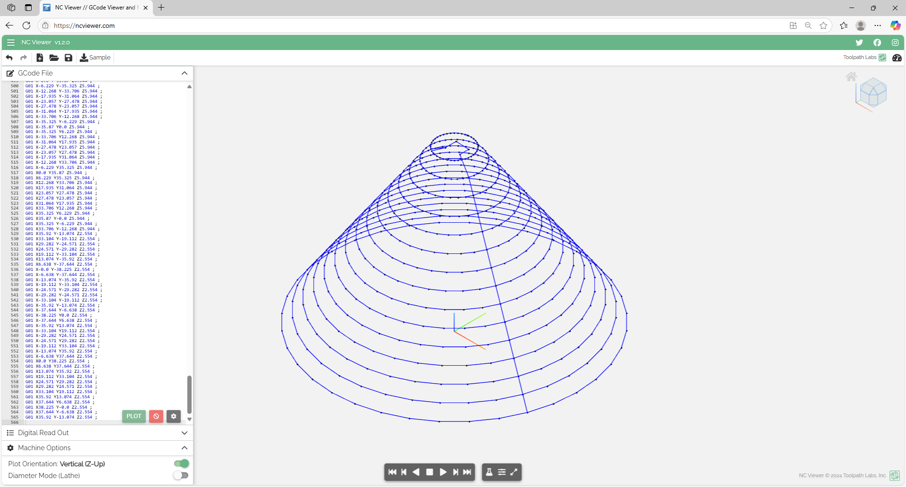
Figure A1: NC Viewer Screenshots of Toolpath Validation [Author, 2025].

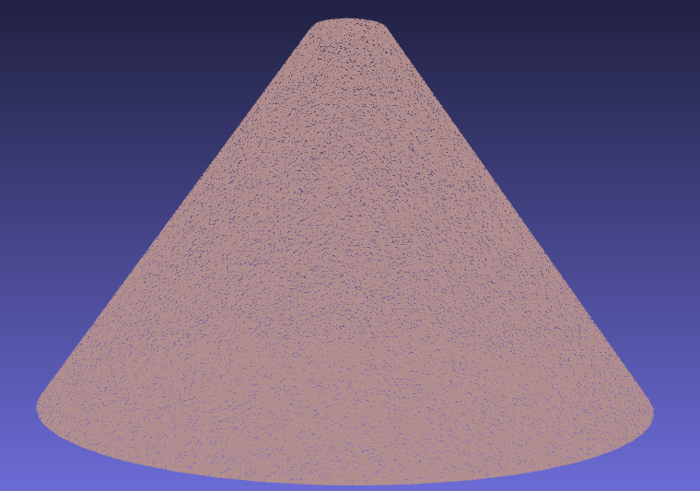
Figure A2: Point Cloud of the Truncated Cone [Author, 2025].

import pandas as pd
import numpy as np
from scipy.spatial import ConvexHull
from stl import mesh

# Configurable parameters
TOOL_DIAMETER = 3.4 # Tool diameter (mm)
Z_SPRINGBACK_OFFSET = -0.1
LAYER_THICKNESS = 1.0
MIN_DISTANCE = 0.5
Z_OFFSET = 50.5
SAFE_Z_RELATIVE = 50.0

# Load STL file and extract points
def load_stl_to_dataframe(stl_file, layer_thickness=1.0):
stl_mesh = mesh.Mesh.from_file(stl_file)
vertices = stl_mesh.vectors.reshape(-1, 3)
df = pd.DataFrame(vertices, columns=['x', 'y', 'z'])
df = df.drop_duplicates().reset_index(drop=True)
df['z'] = np.round(df['z'] / layer_thickness) * layer_thickness
return df.dropna()

# Filter close points to prevent clustering
def filter_close_points(points, min_distance=0.5):
filtered = [points[0]]
for p in points[1:]:
if np.linalg.norm(p - filtered[-1]) >= min_distance:
filtered.append(p)
return np.array(filtered)

# Sort points to prevent doubling back
def sort_points_no_overlap(points):
center = points.mean(axis=0)
angles = np.arctan2(points[:, 1] - center[1], points[:, 0] - center[0])
sorted_indices = np.argsort(angles)
sorted_points = points[sorted_indices]
n = len(sorted_points)
for i in range(n):
p1, p2 = sorted_points[i], sorted_points[(i + 1) % n]
for j in range(i + 2, n):
p3, p4 = sorted_points[j], sorted_points[(j + 1) % n]
if intersects(p1, p2, p3, p4):
sorted_points[i + 1:j + 1] = sorted_points[i + 1:j + 1][::-1]
return sorted_points

# Check if segments intersect
def intersects(p1, p2, p3, p4):
def ccw(A, B, C):
return (C[1] - A[1]) * (B[0] - A[0]) > (B[1] - A[1]) * (C[0] - A[0])
return ccw(p1, p3, p4) != ccw(p2, p3, p4) and ccw(p1, p2, p3) != ccw(p1, p2, p4)

# Smooth hull points
def smooth_hull_points(points, alpha=0.3):
smoothed = points.copy()
for i in range(len(points)):
prev = points[(i - 1) % len(points)]
next = points[(i + 1) % len(points)]
smoothed[i] = (1 - alpha) * points[i] + alpha * (prev + next) / 2
return smoothed

# Apply reverse offset using centroid-based method
def reverse_offset(points, TOOL_DIAMETER=2.5, z_springback_offset=-0.1):
adjusted_points = points.copy()
center = points[:, :2].mean(axis=0)
distances = np.linalg.norm(points[:, :2] - center, axis=1)
layer_radius = distances.max() if distances.size > 0 else 1.0
print(f"Layer at Z={points[0, 2]:.2f}, points={len(points)}, radius={layer_radius:.2f} mm, TOOL_DIAMETER={TOOL_DIAMETER:.2f} mm")
for i, point in enumerate(adjusted_points):
direction = point[:2] - center
norm = np.linalg.norm(direction)
if norm > 1e-6:
direction /= norm
offset = TOOL_DIAMETER * direction
adjusted_points[i, :2] -= offset
print(f"Point {i}: Offset applied = {offset[0]:.2f}, {offset[1]:.2f}")
adjusted_points[i, 2] += z_springback_offset
adjusted_points[:, :2] = smooth_hull_points(adjusted_points[:, :2])
x_min, x_max = adjusted_points[:, 0].min(), adjusted_points[:, 0].max()
y_min, y_max = adjusted_points[:, 1].min(), adjusted_points[:, 1].max()
adj_distances = np.linalg.norm(adjusted_points[:, :2] - center, axis=1)
adj_layer_radius = adj_distances.max() if adj_distances.size > 0 else 1.0
print(f"Adjusted radius={adj_layer_radius:.2f} mm")
print(f"Bounding box: X=[{x_min:.2f}, {x_max:.2f}], Y=[{y_min:.2f}, {y_max:.2f}]")
return adjusted_points

# Load reference toolpath from STL file
stl_file = 'test_piece_3.stl'
df = load_stl_to_dataframe(stl_file, layer_thickness=LAYER_THICKNESS)

# Main toolpath generation loop
ll = []
prev_exit_point = None
z_levels = sorted(df['z'].unique(), reverse=True)

# Calculate the desired uniform layer spacing
if len(z_levels) > 1:
z_diffs = [z_levels[i] - z_levels[i + 1] for i in range(len(z_levels) - 1)]
avg_spacing = np.mean(z_diffs)
print(f"Average layer spacing in input data: {avg_spacing:.3f} mm")
else:
avg_spacing = 1
print("Only one Z level in input data, using default spacing of 1 mm")

# Reassign Z levels to be uniformly spaced
uniform_z_levels = []
start_z = z_levels[0]
for i in range(len(z_levels)):
new_z = start_z - i * avg_spacing
uniform_z_levels.append(new_z)

# Calculate the center of the first layer for the initial move
center_x, center_y = None, None
for layer_idx, current_layer_z in enumerate(z_levels):
current_layer = df[df['z'] == current_layer_z][['x', 'y', 'z']].values
if len(current_layer) >= 5:
center_x, center_y = current_layer[:, :2].mean(axis=0)
break
if center_x is None or center_y is None:
print("Warning: Could not compute center from any layer. Using (0, 0) as fallback.")
center_x, center_y = 0.0, 0.0

# Process each layer with the new uniform Z levels
for layer_idx, current_layer_z in enumerate(z_levels):
current_layer = df[df['z'] == current_layer_z][['x', 'y', 'z']].values
if len(current_layer) < 5:
print(f"Skipping layer at Z={current_layer_z:.2f} due to insufficient points ({len(current_layer)})")
continue

layer_points_2d = current_layer[:, :2]
try:
hull = ConvexHull(layer_points_2d)
hull_coords = layer_points_2d[hull.vertices]
except Exception as e:
print(f"Skipping layer at Z={current_layer_z:.2f} due to hull error: {str(e)})")
continue

if hull_coords.shape[0] < 5:
print(f"Skipping layer at Z={current_layer_z:.6f} due to insufficient hull vertices ({hull_coords.shape[0]})")
continue

hull_coords = filter_close_points(hull_coords, min_distance=MIN_DISTANCE)

hull_z = np.full((hull_coords.shape[0], 1), uniform_z_levels[layer_idx])
hull_points_3d = np.hstack([hull_coords, hull_z])

adjusted_points_3d = reverse_offset(hull_points_3d, TOOL_DIAMETER=TOOL_DIAMETER, z_springback_offset=Z_SPRINGBACK_OFFSET)
adjusted_points_2d = adjusted_points_3d[:, :2]

sorted_points = sort_points_no_overlap(adjusted_points_2d)

# For the first layer, start at the point closest to the centroid
if layer_idx == 0:
centroid = np.array([center_x, center_y])
dists = np.linalg.norm(sorted_points - centroid, axis=1)
start_idx = np.argmin(dists)
sorted_points = np.roll(sorted_points, -start_idx, axis=0)
elif prev_exit_point is not None:
dists = np.linalg.norm(sorted_points - prev_exit_point[:2], axis=1)
start_idx = np.argmin(dists)
sorted_points = np.roll(sorted_points, -start_idx, axis=0)

sorted_layer = np.hstack([sorted_points, np.full((sorted_points.shape[0], 1), adjusted_points_3d[0, 2])])
layer_path = list(sorted_layer)
layer_path.append(layer_path[0]) # Close the loop
ll.extend(layer_path)
prev_exit_point = layer_path[0]

if len(ll) == 0:
print("Warning: No toolpath points generated. Check input data or layer filtering.")
exit()

# Apply Z offset to drop the toolpath
ll = np.array(ll)
ll[:, 2] -= Z_OFFSET # Subtract z_offset from all Z coordinates

# Round toolpath coordinates to 2 decimal places
ll = np.round(ll, 2)

# Save toolpath to CSV
pd.DataFrame(ll, columns=['x', 'y', 'z']).to_csv('toolpath.csv', index=False)

# Convert to G-code
df_ltp = pd.read_csv('toolpath.csv')

# Round coordinates to 2 decimal places and format explicitly
df_ltp['x'] = df_ltp['x'].round(2)
df_ltp['y'] = df_ltp['y'].round(2)
df_ltp['z'] = df_ltp['z'].round(2)

df_gchord = pd.DataFrame({
'G': 'G01',
'x': 'X' + df_ltp['x'].map('{:.2f}'.format),
'y': 'Y' + df_ltp['y'].map('{:.2f}'.format),
'z': 'Z' + df_ltp['z'].map('{:.2f}'.format),
'EOB': ';'
})

first_x = round(df_ltp.iloc[0]['x'], 2)
first_y = round(df_ltp.iloc[0]['y'], 2)
first_z = round(df_ltp.iloc[0]['z'], 2)

# Modified G-code header to start from the centroid
gcode_header = [
"G90 ; (Absolute positioning)",
"G21 ; (Set units to millimeters)",
"M03 ; (Start spindle)",
"S500 ; (Setting spindle speed)",
"F1000 ; (Set feedrate)",
f"G00 X{center_x:.2f} Y{center_y:.2f} ; (Rapid move to centroid)",
f "G01 Z{first_z:.2f} ; (Drop to first point's Z)",
f"G01 X{first_x:.2f} Y{first_y:.2f} ; (Move to first toolpath point)"
]

last_x = round(df_ltp.iloc[-1]['x'], 2)
last_y = round(df_ltp.iloc[-1]['y'], 2)

# Final safe Z is relative to the last point's Z position
last_z = df_ltp.iloc[-1]['z']
final_safe_z = last_z + SAFE_Z_RELATIVE

gcode_footer = [
f"G01 X{last_x:.2f} Y{last_y:.2f} Z{final_safe_z:.2f} ; (Retract tool to safe Z)",
"M30 ; (End of program)"
]

with open('Gchord.txt', 'w') as f:
for line in gcode_header:
f.write(line + '\n')
df_gchord.to_csv(f, index=False, sep=" ", header=False, mode='a')
for line in gcode_footer:
f.write(line + '\n')
Code A1: Complete Python CAM System Code [Author, 2025].
%pip install pandas
%pip install scipy
%pip install numpy-stl
Code A2: Libraries required to download
import pyvista as pv
import csv
import pandas as pd
import numpy as np

# Load STL file
mesh = pv.read('test_piece_3.stl')
points = mesh.points

# Export point cloud to CSV
with open('dots.csv', 'w') as f:
writer = csv.writer(f)
writer.writerows(points)

# Process point cloud
df = pd.read_csv('dots.csv')
df = df.dropna()
df = df.set_axis(['x', 'y', 'z'], axis='columns')
maxi = df['z'].max()
mini = df['z'].min()
df = df[df['z'] > mini + 0.01]
df.to_csv('dots.csv')
df = pd.read_csv('dots.csv')
ll = np.array([0, 0, 0])
pp = np.array([0, 0, 200])

# Toolpath generation loop
while len(df) > 0:
s = df['z'].max()
df_z = df[df['z'] == s]
df_z.to_csv('layer.csv')
df_z = pd.read_csv('layer.csv')
df_z = df_z.drop(df_z.columns[[0, 1]], axis=1)
df_z.to_csv('layer.csv')
l = np.loadtxt('layer.csv', delimiter=',', dtype='float64', skiprows=1, usecols=[1, 2, 3])
n = len(df_z)
c = 0
ltp = np.array([0, 0, 0])
if n > 1:
while n > 0:
ld = [np.linalg.norm(pp - l[j]) for j in range(n)]
k = ld.index(min(ld))
lk = l[k]
ltp = np.vstack([ltp, lk])
if c == 0:
llk = lk
l = np.delete(l, k, 0)
n -= 1
pp = lk
c += 1
ltp = np.delete(ltp, 0, 0)
ll = np.vstack([ll, ltp])
df = df[df['z'] < s]
ll = np.round(ll, 3)
with open('toolpath.csv', 'w') as f:
writer = csv.writer(f)
writer.writerows(ll)

# G-code conversion
df_ltp = pd.read_csv('toolpath.csv')
df_ltp = df_ltp.set_axis(['x', 'y', 'z'], axis='columns')
l = np.loadtxt('toolpath.csv', delimiter=',', dtype='float64', skiprows=1, usecols=[1, 2, 3])
lx, ly, lz = l[:, 0], l[:, 1], l[:, 2]
lx = ['X' + str(x) for x in lx]
ly = ['Y' + str(y) for y in ly]
lz = ['Z' + str(z) for z in lz]
df_gchord = pd.DataFrame({'G': 'G01', 'x': lx, 'y': ly, 'z': lz, 'EOB': ';'})
df_gchord.to_csv('Gchord.txt', index=False, sep=" ")
Code A3: Previous research’s CAM system
Starting the machine:
- Press the button to the left of the power button (the button has the word "source" written on it)
- Turn the mode to auto to ensure that the toolpath can be run
- Wait for the machine to output a large green button in the center of the screen with power written on it
- Press the power button that is next to the controller
- For the 3 x 3 origin point, the order of finding the origin is from top to bottom, and right to left is the priority of the origin setting.
- Go to "Files" from the menu bar at the bottom of the screen; grey boxes represent them.
- Select the middle gray button to select the "machine warm up (E25-sprun3M... )" NC code found in the files menu->HDD1 -> E25-sprun3M... (This process takes about 45 min to an hour)
- Do not forget to press the execute button (実行) that is in the bottom right corner of the screen. (you might need to navigate to find it)
- After sections 7 and 7a press the cycle start and wait 45 to an hour.
While the machine is warming up:
- Turn on the computer and select the profile that is in the middle
- The name is something like "pel2014," and the password is "pelpel."
- Double-click the "GCode" shortcut on the desktop
- Drag the code from the USB to that folder
Setting the origin for the tool:
- After the warmup process, must "zero" or find the origin with respect to the jig
- Ensure the "thicker tool" is attached; if not, follow the steps below. If it is already in, then skip to 10c.
- To do so, you must switch the tool out by pressing the tool switch button (near the bottom left of all the buttons)
- the tool will fall out, so be ready to catch it
- Using the manual adjustment and having the tool spin by pressing the sp cw button, have the tool touch the outer part of the jig until the tool aligns
- Perform this step twice for both the X and Y directions to ensure the zero is accurate. Ensure that you press the "zeroing button" on the screen after every touch.
- To perform the "zeroing" for the Z direction, place the "green light" device on the material and slowly lower the tool until the light turns on. Then, raise the tool and repeat this process two more times.
- Ensure that you add 5 mm to the zeroing after the main jig has been zeroed. This is to ensure room for error.
- After this, move to the center of the machine shape. (make sure to move the origin off by the amount that your tool will move on its initial movement for an offset. For example, if the first movement of the tool from the origin is to X 10 Y 10 Z 10, then offset the origin by X - 10 Y - 10 Z -10 so that the tool will make contact with the workpiece.)
- Go back to the machine, select the code, and let it run after the warmup is finished
- Set the "Feed rate %" dial to 0 before executing in order to make sure that it does not move too fast on start-up
- "Cycle start" to start the program
Figure A3: Start up procedures for the machining center.

Chapter 6: References
- Bagherifard, S., Ghelichi, R., & Guagliano, M. (2018). Shot peening: A review of the process and its applications. Journal of Materials Processing Technology, 258, 188–202.
- Duflou, J. R., Habraken, A. M., Cao, J., Malhotra, R., Bambach, M., Adams, D., ... & Merklein, M. (2018). Single point incremental forming: An assessment of the progress and technology trends from 2005 to 2015. Journal of Manufacturing Processes, 28(3), 373–391. https://doi.org/10.1016/j.jmapro.2017.04.015
- Guttag, J. V. (2021). Introduction to computation and programming using Python (3rd ed.). The MIT Press.
- Ikari, T., & Tanaka, H. (2023). Feasibility study of laser-assisted incremental forming for carbon fiber reinforced thermoplastic based on 3D CAD data. Sophia University Technical Report.
- Ikari, T., & Tanaka, H. (2023). Feasibility study of single point incremental forming for discontinuous fiber CFRP using oil bath heating. Sophia University Technical Report.
- Mitsumori, T. (2023). Development of incremental forming techniques for automotive CFRP components. Sophia University Technical Report.
- Sharma, V., Sharma, V., & Shukla, O. J. (2014). Principles and practices of CAD/CAM. Katson Books.
- Shovic, J. C., & Simpson, A. (2021). Python all-in-one for dummies. Wiley.
- Smid, P. (2006). CNC programming techniques. Industrial Press.
- Tanata, H. (2023). Carbon-fiber-reinforced-polymer manufacturing techniques. Sophia University Technical Report.
- Radiolucent Carbon Fiber–Reinforced Pedicle Screws for Treatment of Spinal Tumors: Advantages for Radiation Planning and Follow-Up Imaging - ScienceDirect
- ([PMC: State of the Art in Incremental Forming](https://pmc.ncbi.nlm.nih.gov/articles/PMC11642863/)).
- [ScienceDirect: Incremental Forming](https://www.sciencedirect.com/topics/engineering/incremental-forming).
- The technology of Incremental Sheet Forming—A brief review of the history - ScienceDirect
- Bachmann, Jens & Hidalgo, Carme & Bricout, Stéphanie. (2017). Environmental analysis of innovative sustainable composites with potential use in aviation sector—A life cycle assessment review. Science China Technological Sciences. 60. 10.1007/s11431-016-9094-y.

